**SMS Sender**

1. For now we will use the fast2SMS’s api for sending the sms
2. Fast2SMS provide the following types sms, services:

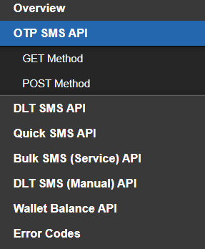

1. For now we will use the OTP sms api